Avnu Alliance®

Plugfest Welcome Packet

Version .06 –February 20, 2024

Author

Kim Lewis

Contributors
Ed Agis - Intel
Fran Garcia – Keysight
Marty Gubow – Keysight

Executive Summary
This document is intended to be a resource for when you are attending one of Avnu Alliance’s sanctioned Plugfests. This document will be updated for each plugfest due to the change in host and location. It includes valuable information about attending the plugfest

About Avnu Alliance
Avnu Alliance is a community creating an interoperable ecosystem of low-latency, time-synchronized, highly reliable networked devices using open standards. Avnu creates comprehensive certification programs to ensure interoperability of networked devices. The foundational technology enables deterministic synchronized networking based on IEEE Audio Video Bridging (AVB) / Time Sensitive Networking (TSN) base standards. The Alliance, in conjunction with other complementary standards bodies and alliances, provides a united network foundation for use in professional AV, automotive, industrial control and consumer segments.
© 2021 by Avnu Alliance. All rights reserved. Avnu™, Avnu Alliance®, and the Avnu® and Milan® design and logos are trademarks of the Avnu Alliance. All other names and logos are trademarks and/or service marks of their respective owners. Specifications and content subject to change without notice.
THIS DOCUMENT IS PROVIDED "AS IS" WITH NO WARRANTIES WHATSOEVER, EXPRESS, IMPLIED, OR STATUTORY. AVnu Alliance MAKES NO GUARANTEES, CONDITIONS OR REPRESENTATIONS AS TO THE ACCURACY OR COMPLETENESS CONTAINED HEREIN.
Avnu Alliance disclaims all liability, including liability for infringement, of any proprietary or intellectual property rights, relating to use of information in this document. No license, express or implied, by estoppel or otherwise, to any proprietary or intellectual property rights is granted herein.

Welcome Note from Ed Agis and Genio Kronauer – Your Certification Work Group Co-Chairs
We would like to welcome you to the upcoming Avnu Plugfest which is being hosted by Keysight, in Málaga, Spain from April 1st through April 5th , 2024. Preparations for this plugfest began back in December in order to prepare all the materials and schedules you will need to have a successful event and to assist you with getting your products ready for commercial deployment. As part of our certification program, this plugfest and others planned throughout the year will enable our Avnu members to continue to build a strong ecosystem of products. If you have any questions regarding the registration process or the materials available for our plugfest, please reach out to our technical program manager at Avnu TPM tpm@avnu.org, at any time. Shortly after we have closed out the registration for the plugfest, we will coordinate a call with all of the registrants to finalize any other actions that may need you attention in order to have a successful event. We are looking forward to seeing you in Málaga and please take time to fill out all of the required documents that we have provided for the registration of this event.
Regards,
Avnu Certification Co-Chairs
Ed.agis@intel.com
Genio.kronauer@l-acoustics.com

Welcome Note from Host Lab

We are delighted to be hosting the Avnu Plugfest. On behalf of Keysight I extend you a very warm welcome and trust this Plugfest will be productive and successful.
Address of event
Keysight Technologies
Parque Tecnológico de Andalucía
C/ Severo Ochoa, 16-20
Edificio Alora
29590 Campanillas
Spain

Airport Contact

www.aena.es/
P.O. BOX 371.
Avda. Comandante García Morato, s/n. 29004 Málaga
Tel.: (34) 91 321 10 00
infoagp@e-externas.aena.es

Contact/ Event coordinator

Fran Garcia

Wireless Devices and Operator Segment Division

fran_garcia@keysight.com

+34 951 51 00 48

Custom/Shipping address
Parque Tecnológico de Andalucía
C/ Severo Ochoa, 16-20
Edificio Alora
29590 Campanillas
Spain

Monday – Thursday: 8h – 13h and 14h-17h
Friday 8h-15h

Recommended Date Attendees need to Ship by:

Please ship at least 2 weeks before intended receiving date when shipping from the US to Spain.

Recommendations for Transportation to location

https://www.pta.es/en/how-to-get/

It is recommended to take a Taxi to Keysight from Hotel or airport.

Public transportation from Malaga City Center (Plaza de la Marina) to Keysight Technologies:

- By car/ taxi (15-20min drive for around 16km): https://maps.app.goo.gl/TdbMKcMXko2hgFfc9
- By bus number 25 from Malaga City Center (40min drive): https://maps.app.goo.gl/ibzdZK766uSgipov6

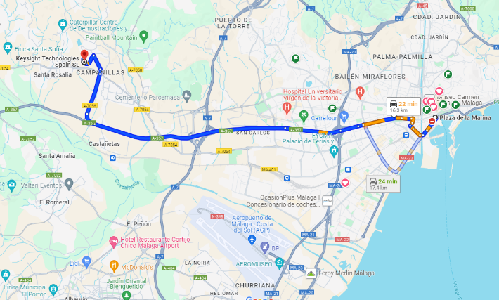

- Local Taxi Services

Unitaxi +34 952 33 33 33
TeleTaxi +34 693 718 108
Radiotaxi: +34 952 040 804

- Alternatives to taxi:
Our recommendation as an alternative and easy-to-use taxi service is Uber, Cabify or Bolt.

Time-zone
At the time of the meeting, the time zone will be CET (Central European Time), UTC+01.00.

Currency
The monetary unit is the Euro (€).

Power Outlets & Voltage
The type of plug used mainly in Spain, and in most countries in Europe, is the type C which consists of two round parallel pins while the wall plug has two holes where it is connected.  Voltage is 230V, 50 Hz (cycles). | 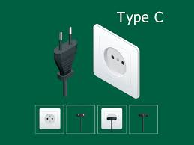

Major Accepted credit cards:
-Visa
-Mastercard
-Maestro

Note American Express are typically not accepted. In higher class hotels/shops and restaurants American Express are accepted.

Typical Hours of Business Operations for the Week:

Monday - Saturday shopping center will start at 10.00a.m. and close at 10.00p.m.
Sunday most shops are closed.
Exception: some shops at Downtown (Calle Larios), at international airport or train station are still open on Sunday. Check online. Depends on the season.

Hotels
Recommendations/Contacts
- Hotel AC Malaga Palacio by Marriot – Calle Cortina del Muelle, 1, Distrito Centro, 29015 Málaga
+34 952 21 51 85
- Molina Lario Hotel - C. Molina Lario, 20, 8ªPlanta, Distrito Centro, 29015 Málaga
+34 952 06 20 02
- Only You - Alameda Principal, 1, Distrito Centro, 29001 Málaga
+34 910 05 27 46
- NH Hotel - C. San Jacinto, 2, Distrito Centro, 29007 Málaga
+34 952 07 13 23
- Gran Hotel Miramar - Paseo de Reding, 22-24, 29016 Málaga, Spain
+34 952 603 000

- Hilton Garden Inn Malaga (Close to Malaga Airport) - Av. de Velázquez, 126, Carretera de Cádiz, 29004 Málaga

+34 952 23 31 22

Restaurants in the Area:

- Palocortado Málaga
- Lola Restaurant
- El Refectorium Catedral
- El Trocadero
- La Pergola
- La Sole del Pimpi
- Restaurante Matiz
- El Verum
- El Pez Wanda
- Restaurante Marisqueria el Godoy

Links to Tourist sites/information:

Discover Malaga:
https://www.spain.info/en/destination/malaga/

Tourist-Information:
https://visita.malaga.eu/en/
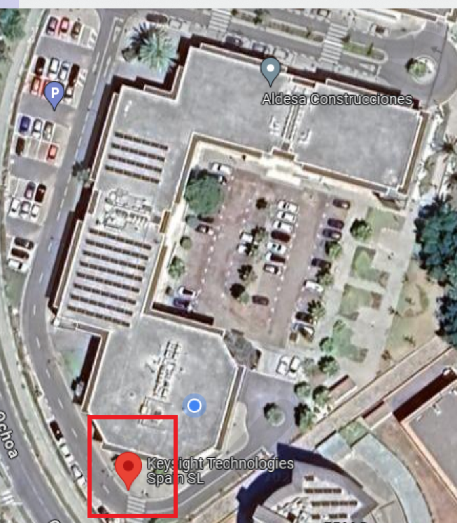
Anticipated Weather:
https://www.aemet.es/en/eltiempo/prediccion/municipios/malaga-id29067

Overall Meeting Schedule:

Monday – Plugfest 8:00 - 5:00
Tuesday – Plugfest 8:00 - 5:00
Wednesday – Plugfest 8:00 - 5:00
Thursday –Demonstration 10:00 – 12:00 noon
Roadmap sharing 1:00 – 4:00
Friday – Dismantle/ pack 8:00 – 12:00 noon

Check in location once on site:

Keysight Malaga Reception

Parking instructions: if needed

- Blue Zone: Need to buy a ticket or register the parking in Telepark
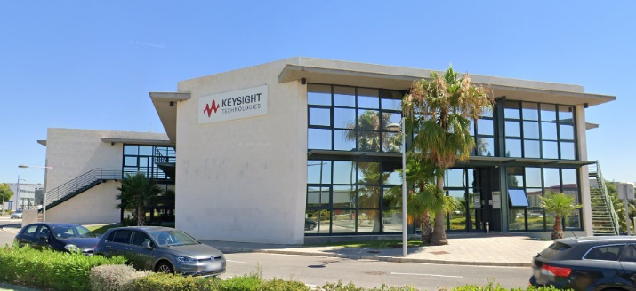
https://www.telpark.com/en/cities/malaga/?type=public_road

- Contact Keysight for further information.

Keysight Technologies premises:
Full name, Nationality and company must be provided in order to get access to Keysight Technologies.

